**REVISTA INVESTIGACIÓN OPERACIONAL VOL 44, NO.1, 114-128, 2023**

**A HYBRID GENETIC ALGORITHM FOR OPTIMIZING URBAN DISTRIBUTION OF AUTO-PARTS BY A VERTEX ROUTING PROBLEM**

Israel D. Herrera-Granda[1]*, **, Carlos Martin-Barreiro**, ***, Erick P. Herrera-Granda****, Yasmany Fernández-Fernández****, and Diego H. Peluffo-Ordoñez*****

*Universidad Politécnica de Valencia, Escuela de Doctorado en Ingeniería y Producción Industrial, Valencia, España **Escuela Superior Politécnica del Litoral, ESPOL, Facultad de Ciencias Naturales y Matemáticas, FCNM, Guayaquil, Ecuador.

*** Universidad de Salamanca, Departamento de Estadística, Salamanca, España.

****Universidad Politécnica Estatal del Carchi, Tulcán, Ecuador.

*****Corporación Universitaria Autónoma de Nariño, Pasto, Colombia.

**ABSTRACT**

The present work designed and implemented a hybrid algorithm by combining the genetic algorithm meta-heuristics (GA) with the nearest neighbor algorithm (NN). We combined these algorithms to solve the Capacitated Vehicle Routing Problem with Time Windows and a single depot (CVRPTW). The proposed implementation optimizes the distribution for an auto-part trading company within the urban perimeter of Quito city – Ecuador, by designing a script coded in C# language. Besides, to evaluate the quality of the solutions generated by the proposed hybrid algorithm, different instances of the problem were built by taking small samples from the whole customer's information. To compare the performance of our algorithm, we used a VRPTW model encoded in GAMS. In addition, we applied the problem from the case-study company in real instances. As a result, the generated sequences of the routes travelled by the trucks reach an improvement of close to 20%. We calculated that percentage using the Euclidean metric.

**KEYWORDS:** Distribution of auto parts, VRP, Genetic algorithms, Heuristic, Urban logistics.

**MSC:** 78M32, 90B99

**RESUMEN**

En el presente trabajo se diseñó e implementó un algoritmo híbrido que combina la metaheurística del algoritmo genético y la heurística del vecino más cercano, con la intención de resolver el problema del ruteo vehicular capacitado con ventanas de tiempo y un solo depósito (CVRPTW). El objetivo de tal implementación es optimizar la distribución de autopartes para una empresa comercializadora, al interior del perímetro urbano de la ciudad de Quito-Ecuador. Como parte de la implementación, se desarrolló un software programado en el lenguaje C#. Posteriormente, para poder evaluar la calidad de las soluciones entregadas por el algoritmo híbrido propuesto, se construyeron diferentes instancias del problema, tomando pequeñas muestras de clientes, y se comparó dichas soluciones con las soluciones exactas que se obtuvieron al programar el modelo matemático del CVRPTW en el software de optimización GAMS. Finalmente, se resolvieron instancias reales del problema, y se obtuvieron secuencias de rutas que mejoran hasta en un 20% las secuencias de rutas recorridas por el camión repartidor de la empresa utilizando la métrica Euclideana.

**PALABRAS CLAVE:** Distribución de Autopartes, VRP, Algoritmos Genéticos, Heurísticas, Logística Urbana.

**INTRODUCTION**

Recent advances in operations research and the development of mathematical algorithms applied in computer environments to Supply Chain Management problems have demonstrated effective improvements solving the problem of scheduling and designing routes for delivery vehicles [2], [7], [29]. The creation of a mathematical algorithm oriented to improve the routing sequence for delivering vehicles would help the company to optimize its urban distribution system. The Vehicle Routing Problem (VRP) falls within the field of knowledge "Transport Strategy", and this field falls within the field of Supply Chain Management (SCM).

* 1. **A brief review of the state of the art of vehicle routing.**

Initially, in 1959 Dantzig et al, formally presented the VRP, defining it as: "M vehicles are initially located in a warehouse and have to deliver a discrete amount of goods to the $n$ customers. Determine the optimal route that will be used by a group of vehicles when they visit a group of customers" [25].

The VRP problem consist in the fact that, each vehicle must start and finish its journey in the same initial vehicle depot, visiting all the customers mentioned previously. However, the complexity of this problem depends on the characteristics and quantity of each one of them. For example, different types of vehicles (heterogeneous fleet), the number of facilities (several), and other types of restrictions that may be added.

Since the presentation of the VRP, many mathematical models have emerged around this problem trying to model and meet the different requirements of the problem. Therefore, currently there is an extensive base of VRP models that address many of the singularities that have emerged around this issue such as time windows restrictions, turning it in the Vehicle Routing Problem with Time Windows (VRPTW) [9], [23], [17], in which even modern genetic metaheuristic techniques have been applied [30].

Other issues consider the capacity restrictions for the vehicle, turning it in the Capacitated Vehicle Routing Problem (CVRP) [1; 19; 27; 31], which to this day are still classic problems subject to revision and continuous improvement. Once this review was done, we designed the figure 1 that shows a classification and a timeline of the VRP and its comparison with similar problems, such as the Travelling Salesman Problem (TSP) and the Chinese Postman Problem (CPP) [28], [4].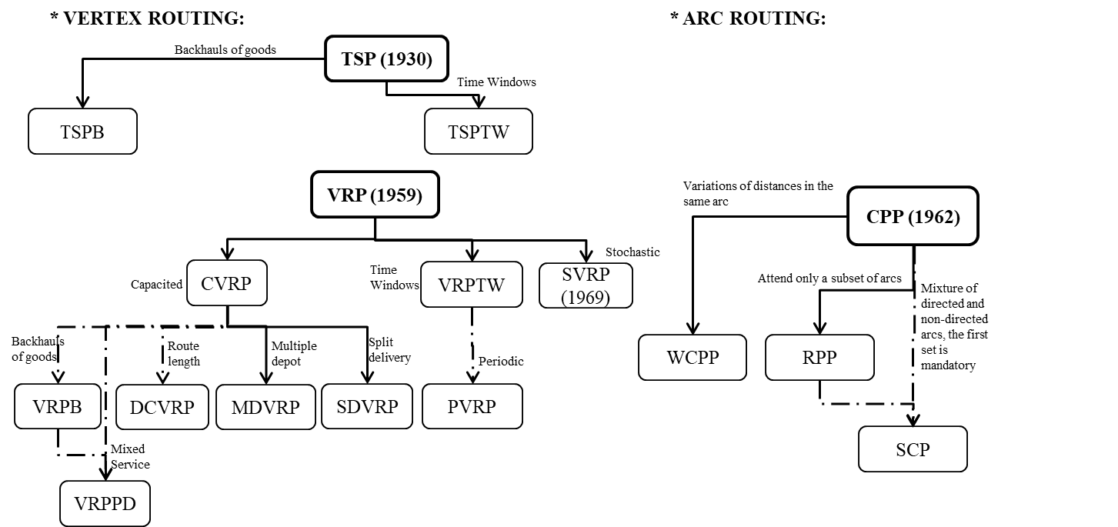

However, as the number of variables and components of each VRP model increases, so Figure 1. Classification of vehicle routing models.

does its computational complexity to be solved, making this problem difficult to solve by exact methods, turning it in a NP-hard problem [29], [11], [30]. In this point the field of metaheuristic optimization has had a boom in terms of its application, since its efficiency in solving this type of problems at reasonable computational costs has been widely demonstrated [20], [30].

Figure 1. Classification of vehicle routing models.

* 1. **Case of study**

This study was proposed to solve the problem of programming and designing sequences of routes for vehicles in an auto parts marketing company. By creating a computer software based on a hybrid metaheuristic procedure that can be used as a guide to optimize the distribution of auto parts within the urban perimeter of the Quito city (DMQ). To this end, the complexity of vehicle traffic in the city was taken into account, due to factors such as the excess of vehicles over the DMQ's road infrastructure. In particular, during peak hours, compliance with regulations such as peak and plate regulation, environmental policies, and regulations regarding maximum permitted weights and dimensions [6]. As shown in Figure 2.

In addition, a technical analysis of the fleet vehicles was carried out, to determine their average fuel consumption and average circulation speed in the urban perimeter of the DMQ [10]. In order to enter these data as parameters for the model. In most cases, real or very close to Figure 2. Case study delimitation reality data was used to provide good results.

In the mentioned company, the operations of distribution of the auto parts

Figure 2. Case study delimitation

within the urban perimeter of DMQ are executed with his own transportation fleet. In addition, it was a policy of this company to fulfill all the requirements and service expectations of its customers, like: deliveries within the agreed time or promise of delivery, schedules for the delivery of the merchandise or Time Windows restrictions (TW), and considering that the capacity of load of the vehicles was limited.

However, in the studied company the same drivers of the delivery vehicles do the programming and design of the sequences of routes empirically. The above-mentioned background evidenced the need of this company to have an adequate system to program and design the sequences of routes of its vehicle fleet.

The problem was solved by implementing a software for the proper design the sequences of routes of the company's vehicles, based on a genetic algorithm metaheuristic (GA), hybridized with the heuristic of the nearest neighbor (NN).

The addresses of the customers were extracted from a real database within the urban perimeter of the DMQ, and were converted to geographical coordinates of latitude and longitude of the customers using Google-Earth software in order to work in a computer environment.

**2. MATERIALS AND METHODS**

**2.1. Geolocation of customers**

To obtain the geographical coordinates of the customers in terms of latitude (X) & longitude (Y) in decimal degrees, the Google Earth Pro 7.1.2.2041 software was used, as shown in Table 1.

The customers were separated into two main zones within the DMQ. The Northern zone contains the extension of territory from the parish of “Calderón” to the northern center of DMQ reaching the sector of “Túneles de San Juan”. From this point to the parish of “Guamaní” at the southern end of the DMQ are called The Southern zone.

Other vehicle routing work specifically addresses the problem of distributing equally the zones assigned to trucks. However, due to limitations, in this paper only the northern zone are analyzed and presented [12], [13].

Table 1. Geolocation of the case study customers

|  |  |  |  |  |  |
| --- | --- | --- | --- | --- | --- |
| Northern route | | | Southern route | | |
| Customer | **X latitude** | **Y longitude** | **Customer** | **X latitude** | **Y longitude** |
| 1 (Base) | -0.128544 | -78.480.709 | 1 (Base) | -0.128544 | -78.480.709 |
| 2 | -0.102861 | -78.451.637 | 15 | -0.248273 | -78.526.518 |
| 3 | -0.109459 | -78.504.374 | 16 | -0.247734 | -78.530.663 |
| 4 | -0.140863 | -78.508.909 | 17 | -0.245199 | -78.532.851 |
| 5 | -0.159030 | -78.483.367 | 18 | -0.246363 | -78.535.597 |
| 6 | -0.190771 | -78.493.173 | 19 | -0.242293 | -78.532.805 |
| 7 | -0.191352 | -78.498.630 | 20 | -0.284000 | -78.536.104 |
| 8 | -0.156914 | -78.466.478 | 21 | -0.348362 | -78.549.076 |
| 9 | -0.210534 | -78.508.489 | 22 | -0.285290 | -78.536.388 |
| 10 | -0.209765 | -78.503.539 | 23 | -0.284501 | -78.536.332 |
| 11 | -0.216231 | -78.503.026 |  |  |  |
| 12 | -0.180076 | -78.488.984 |  |  |  |
| 13 | -0.196156 | -78.494.811 |  |  |  |
| 14 | -0.159710 | -78.477.727 |  |  |  |

**2.2. Characteristics of the goods to be distributed**

The merchandise distributed by the case study company consist in auto parts and mostly automotive batteries whose average weight for each SKU was 17.97 kg. It is important to mention that the average area used by each SKU in the surface of the truck's cargo van had an average of 0.04 m². However, this parameter did not affect the model, since the automotive batteries were heavy and rigid elements that could support a stacking factor of up to three rows for each column of this product.

In addition, considering that the internal loading area of the van was 12 m². Approximately 300 batteries could be placed in each row. If each battery weighed 17.97 kg, the total weight of the load would be approx. 5391 kg. Which exceeds the payload capacity of the truck, which was 4100 kg in only the first load row of the truck. Therefore, there would not be a problem in terms of lack of loading space in the truck, as the weight of a total battery’s charge, even only the first level would exceed the payload capacity of the truck without occupying the entire loading area.

This implies that there were no problems in terms of load overlap for the design of the algorithm. Therefore, the amount of cargo to be delivered to each customer was considered in the model. Later, the program will control the sum of the individual loads of customers. So that, it should not exceed the previously specified truck loading capacity.

**2.3. Customer time windows**

In order to increase the service level to the company's customers, hard Time Windows for the customer visits were included in this study. These Time Windows were in accordance with the operating hours for medium-duty vehicles at the DMQ. That is, the lower time window was at 9:30 a.m. and the upper time window was at 3:30 p.m. for a normal day. However, the time windows had to be made more rigid on the days when a truck was subject to peak and plate regulations.

The reason for establishing such time windows was because the circulation schedules have been established within the DMQ road network for the medium-duty vehicles (CM), i.e., for transit networks or entry and exit routes to urban and perimeter areas, CM´s can circulate from 8:30 p.m. to 6:30 a.m. and from 9:30 a.m. to 3:30 p.m. In the same way, in access road networks that allow the circulation between the different sectors of the DMQ. The company do not have traffic restrictions for CMs circulation on roads that connect different sectors of the city with residential sectors.

In the case of a customer located in the sector of the historical center of DMQ the operations of load and unload for the CM must be executed within the window of time of 20h30 and 06h30 from Monday to Saturday and from 19h30 to 06h30 on Sundays.

**2.4. Calculation of geographical distances**

For the creation of a truck routing model it is important to define a procedure for the calculation of the distance from a pair of nodes belonging to the geographical space XY as a vectorial space [18]. Assume that $i and j$ are a pair of nodes. So, ${\tilde{c}}_{ij}$ is the distance that is incurred when we move from node $i to j$. These distances can be obtained or also called metrics, if it is desired to express these metrics as a mathematical function the following conditions must be fulfilled [3]:

Positivity: $∀i,j {\tilde{c}}_{ij}≥0$.

Identity: $∀i,j {\tilde{c}}_{ij}=0$ if and only if $i=j$.

: $∀i,j {\tilde{c}}_{ij}={\tilde{c}}_{ji}$.

Triangular inequality: $∀i,j,k {\tilde{c}}_{ij}≤{\tilde{c}}_{ik}+{\tilde{c}}_{kj}$

Based on these concepts, two types of metrics will be considered: Euclidean and Manhattan distance.

**2.5. Euclidean distance**

It consists of the distance in a straight line from a pair of nodes. Its disadvantage for the present case of study is that it does not consider the restrictions of the existing road infrastructure and there are no restrictions to transit in any direction. That is why it is frequently used in routing of ships or planes and in land transport only if the geography allows it. This distance can be calculated using the Pythagorean formula of the calculation of the hypotenuse of a triangle. Where, the coordinates of node $i$ are $\left(x_{i},y_{i}\right)$ and the coordinates of node $j$ are $\left(x_{j},y_{j}\right)$, therefore:

${\tilde{c}}_{ij}=\sqrt{{\left(x_{i}-x_{j}\right)}^{2}+{\left(y_{i}-y_{j}\right)}^{2}}$ (1).

**2.6. Manhattan distance**

It assumes the displacement of the vehicle through a grid, which in this case is more adequate to measure the distance within a road infrastructure of the urban type, for this reason, it is very used in urban transport problems. This distance can be calculated using the formula of the sum of the units of measurement for both catheti.

${\tilde{c}}_{ij}=\left|x_{i}-x_{j}\right|+\left|y_{i}-y_{j}\right|$ (2).

**2.7. The problem of Vehicle Routing with Time Windows - VRPTW**

The VRP problem is one of the most studied problems in combinatorial optimization so that for its treatment there are exact and heuristic techniques whose advantages and disadvantages we have already discussed above. The VRP results from the intersection of the Traveling Salesman Problem (TSP) and the Bin Packing Problem (BPP).

*Problem statement:* "Find a set of feasible routes so that each customer is served by a single route and within its respective time window, and above all that the accumulated cost of the routes is as low as possible".

For a feasible route, it must be in an existing road network, which will be transformed into a complete network in which between each pair of vertices $i$& $j$, an arc associated with its distance is defined ${\tilde{c}}_{ij},$ In the same way, you can also associate it in the travel time $t_{ij}$.

The typical objectives of the (VRP) are to Minimize total transportation costs by reducing the total distance traveled or travel times, Minimize fixed costs for vehicle usage. Minimize the total number of vehicles used to serve all customers. Balance or equitably allocate routes assigned to vehicles for travel time and vehicle load. Minimize penalties for partial delivery to customers. Ultimately, increase the service level to customers [29].

The hard time windows specify to the model that each customer must be visited in the previously specified time interval. The soft time windows like the ones above specify a time in which the customer should be visited and a penalty function for the cases when the vehicle is ahead or behind in the visit, these penalties must be according to the objective function.

**Considerations prior to the mathematical model of the VRPTW**

We start by assuming a scenario of multiple depots and customers as input data.

Let a directed network $D=\left(U∪V,A\right)$ with:

$U=\left\{u_{1},u_{2},…,u_{m}\right\}$ (depots)

$V=\left\{v_{1},v_{2},…,v_{n}\right\}$ (customers)

$A=\left\{\left(w_{i},w_{j}\right)/w_{i},w_{j}∈U∪V, w_{i}∈V∨w_{j}∈V\right\}$ (arcs between $i$ to $j$)

The nodes in $U$ represent depots with their capacities $k_{1},k_{2},…,k_{m}$ respectively, where $k_{i}$ represents the number of vehicles of the $i$ depot.

Each depot $u∈U$ contains a homogeneous fleet of vehicles, whose travel costs are given by a vector $c^{u}∈R^{V×V}$.

The nodes in $V$ represent customers and have their respective service times associated $δ_{v},∀v∈V$.

Each customer $v∈V$ has an associated time window $\left[a_{v},b_{v}\right]$ within which the visit to $v$ must begin.

The sum of the arcs between $i$ to $j$ represent a complete tour $W, w∈W∧W⊂A$.

**Formalization**

**Modified travel costs:**

$\tilde{c}{u \atop w\overline{w}}=\left\{\begin{aligned}c{u \atop w\overline{w}}+δ_{\overline{w}} if \overline{w}∊V \\ c{u \atop w\overline{w}} otherwise\end{aligned}\right.$ (3).

**Compatibility between customer’s nodes**

The $\left(v,\overline{v}\right)$ is an ordered pair of compatible customers if any vehicle can visit to $\overline{v}$ immediately after to $v$. That is to say:

$$∃u∈U: a_{v}+{\tilde{c}}_{w\overline{w}}^{u}≤b_{\overline{v}}$$

**Types of arcs**

Exit arcs: $A_{s}=\left\{\left(u,v\right)/u∈U,v∈V\right\}$

Return arcs: $A_{r}=\left\{\left(v,u\right)/u∈U,v∈V\right\}$

Connection arcs: $A_{c}=\left\{\left(v,\overline{v}\right)/v,\overline{v}∈V;\left(v,\overline{v}\right) is a compatible connection\right\}$

**Routes**

An $r-path$ is a directed closed circuit containing exactly one node of $u∈U$:

$r=\left(u,{\overline{v}}_{1},{\overline{v}}_{2},…,{\overline{v}}_{k},u\right)$ with ${\overline{v}}_{1},{\overline{v}}_{2},…,{\overline{v}}_{k}∈V$ (4)

**Feasible routes**

Suppose that $\left\{r_{1},r_{2},…,r_{s}\right\}$ represents the set of all possible routes. It is established that a route is feasible if each customer node is visited within its respective time window:

$∀j=1,2,3,…,k: a_{{\overline{v}}_{j}}≤{\tilde{c}}_{u{\overline{v}}_{1}}^{u}+\sum_{s=1}^{j-1}{{\tilde{c}}_{{\overline{v}}_{s}{\overline{v}}_{s+1}}^{u}}≤b_{{\overline{v}}_{j}}$ (5)

**Cost or duration of the routes**

$c\left(r\right)={\tilde{c}}_{u{\overline{v}}_{1}}^{u}+\sum_{s=1}^{k-1}{{\tilde{c}}_{{\overline{v}}_{s}{\overline{v}}_{s+1}}^{u}}+{\tilde{c}}_{{\overline{v}}_{k}u}^{u}$ (6)

**Decision variables**

$x_{w\overline{w}}^{u}=\left\{\begin{matrix}1 if \left(w,\overline{w}\right) is used on one of the routes of u∈U \\ 0 otherwise\end{matrix}\right.$ (7)

**Time for visiting customers**

$∀v∈V: T_{v}∈R$ (8)

The $T_{v}$ variable represents the time in which a customer is visited.

**2.8. Mathematical model of VRPTW**

The mathematical model with Mixed Integer Programing (MIP) [5], [14], [28] for the solution of VRP in the case study is explained below.

**Objective function**

The objective is to minimize the total cost of travel to all customer nodes assigned to each route

$Min \sum_{u∈U}{\sum_{\left(w,\overline{w}\right)∈A}{{\tilde{c}}_{w\overline{w}}^{u}}} x_{w\overline{w}}^{u}$ (9)

**Restrictions**

Only one route is assigned for each customer:

$\sum_{u∈U}{\sum_{\left(v,w\right)∈A}{x_{vw}^{u}}}=1, ∀v∈V$ (10)

Everything that enters from an arc to a customer is equal to everything that leaves from a customer to an arc, or known as "conservation of flow":

$\sum_{\left(w,v\right)∈A}{x_{wv}^{u}}=\sum_{\left(v,w\right)∈A}{x_{vw}^{u}}, ∀v∈V ∀u∈U$ (11)

Restriction of subtours, i.e. there cannot be full tours that do not pass through all customers:

$\sum_{v,\overline{v}∈W}{x_{v\overline{v}}^{u}}≤\left|W\right|-1, ∀W⊆V ∀u∈U$ (12)

For each guided tour (travelling from a depot $u$ to a customer $v$), starting originally from a depot $\tilde{u}$, at the end of this tour you must return to the same depot $\tilde{u}$:

$\sum_{\left(u,v\right)∈A}{x_{uv}^{\tilde{u}}}+\sum_{\left(v,u\right)∈A}{x_{vu}^{\tilde{u}}}≤0, ∀u,\tilde{u}∈U, u≠\tilde{u}$ (13)

The number of vehicles departing from a depot or to a customer $v$ must not be greater than the capacity in number of vehicles supported by that depot $u$:

$\sum_{\left(u,v\right)∈A}{x_{uv}^{u}}≤k_{u}, ∀u∈U$ (14)

The time that elapses from the time the truck leaves the depot until it visits the customer $T_{v}$ is entered, and this must be within the customer's time window $[a_{v}, b_{v}]$. That time window must be strongly respected (hard window of time):

$a_{v} ≤T_{v} ≤b_{v}, ∀v∈V$ (15)

Linking compatible customer arrival times ($v,\overline{v})$, plus eliminate the sub-tours. This means that the arrival time to the next node $(T_{\overline{v}})$ must be greater than or equal to the time in the predecessor node $(T_{v})$ plus the predecessor arc translated in time ${\tilde{c}}_{v\overline{v}}^{u}$. This happens if the vehicle $k$ travel from $v$ to $\overline{v}$:

$x_{v\overline{v}}^{u}\left(T_{v}+{\tilde{c}}_{v\overline{v}}^{u}-T_{\overline{v}}\right)=0, ∀\left(v,\overline{v}\right)∈A_{c},∀u∈U$ (16)

If the customer is visited within its time window the route is feasible, i.e. there is a connection between the node or depot and the customer $v (x{u \atop uv}=1)$. In that case the arc predecessor translated in time $\tilde{c}{u \atop uv}$ must be equal to the $T_{v}$ which determines the time it takes for a vehicle to reach the customer $v$:

$x_{uv}^{u}\left({\tilde{c}}_{uv}^{u}-T_{v}\right)=0, ∀\left(u,v\right)∈A_{s},∀u∈U$ (17)

Assignment of an arc $\overline{w}$ of a compatible node to the pat,; in the case that it is assigned to the path: $x{u \atop w\overline{w}}$ = 1, and when it's not assigned to the route: $x{u \atop w\overline{w}}$ = 0:

$x_{w\overline{w}}^{u}∈\left\{0,1\right\}, ∀u∈U,∀w,\overline{w}∈V$ (18)

**2.9. Genetic Algorithm (GA) design**

For the present study, we will treat the CVRPTW with a single depot. For this purpose, a variant of the GA proposed by Michalewicz et al. [22], [15], [16], [24], hybridizing this GA with the Nearest Neighbor heuristic (NN) [20], to improve the selection process of the initial population. The following is a detail of the most important points of the implementation.

Genetic architecture: The codification chosen to represent the chromosomes or individuals and even the solution of the problem, consist in chains of integer numbers that correspond to customer nodes in which the truck had to arrive from an initial base node. In other words, a chromosome represents the sequence of the customer's visit by completing a tour of the truck.

Size of the initial population: an initial population of 50 individuals was defined, since it is not recommended to use an initial population with more than 100 individuals due to a premature convergence in the optimal could happen [21].

Evaluation: a method was established to evaluate the aptitude of each child or solution based on the established in the Objective function, determining the total cost or distance traveled on that route or individual.

Additionally, in order to restrict the computer workload, the number of generations produced by the AG has been restricted to at least 10 [21].

Algorithm 1 shown the GA pseudo-code used while, Algorithm 2 shown the pseudo-code of the NN heuristic, which was included within the GA to improve the selection process of the initial population.

**Algorithm 1:** Genetic Algorithm (GA) hybridized with the Nearest Neighbor's (NN) heuristic

1. **BEGIN** /*hibridized GA for VRPTW*/
2. **Generate** an **initial population** with a predefined (*population size, $ps≥50$*) using NN heuristic (see Algoritm 2 for details).
3. **Compute** the **evaluation function** of each individual in the **initial population**.
4. **WHILE** Finished = FALSE **DO**
5. **BEGIN** /*To produce a new generation*/
6. **FOR** (**initial population** size/2) **DO**
7. **BEGIN** /*Reproductive cycle*/
8. **Selection by tournament**: select two individuals from the previous generation for subsequent crossing, the probability of selection will be based on the **evaluation function** of each individual.
9. **Crossing based on a partial correspondence (PMX):** cross the two individuals previously selected obtaining two descendants.
10. **Change-based mutation (SM):** mutating the two descendants.
11. **Compute the evaluation function** of both mutated descendants.
12. **Insert** the two mutated descendants into the **new generations**.
13. The number of **new generations** previously defined $(number of new generations, ng≥10)$ has been reached.
14. **END**
15. **END**
16. **END**
17. **IF** the **population** has converged **THEN**
18. Finished:= **TRUE**
19. **END**
20. **END**

The Nearest Neighbor heuristic (NN) applied to TSP tries to construct a Hamiltonian cycle of minimum total distance, based on the closest vertex to a given vertex. The NN begins selecting the lowest cost edges, however in the final stages of the process there will be vertex that connect to the high cost edges which is called myopia of the procedure. Let $V$: a set of vertex, and $ctj$: the cost to travell from $t$ to $j$ [20].

**Algorithm 2:** Nearest Neighbor heuristic (NN)

1. **BEGIN** /*NN to generate an **initial population**\*/
2. **Selection:** select a vertex randomly
3. **DO $t=j y W=V \backslash \{j\}.$**
4. **WHILE $\left(W≠Ø\right)$**
5. **Take** an $j∊W/ctj=min\{cti/i∊W\}$
6. **Connect $t to j$**
7. **Do $W=W\backslash \left\{j\right\} and t=j$**
8. **END**

**2.10. Implementation of GA**

In order to solve the problem of planning the sequences of routes serving the studied company's customers in the urban perimeter of DMQ. A GA model had to be applied whose objective function is based on the VRPTW model with the addition of a restriction to limit the load capacity of the vehicle.

Under this approach, this routing algorithm was implemented under the C# programming language included in the Visual Studio 2012 package, the customer database was managed through the Office Acces 2007 program. We used a computer, Intel Core i5 CPU M480 @ 2.67GHz, 4.0GB RAM, 64 bits operating system.

Next, a user-friendly application was designed, in which the data must be entered within the different forms. That is, you must select each of the customers to assign them to the route. Within that form, you must also choose the metric to be used for the calculation of geographical distances between Euclidean or Manhattan. In addition, you can select the type of circuit to be used bet. That is to say, you must select either "open circuit": in which a starting point and an end point of the route must be defined, or "closed circuit": in which you must define a single point that will be the start and end of the route as in the case of the TSP.

Additionally, a restriction has been included to check the sum of load of the customers assigned to the route so that it do not exceed the 4100 kg of truck load capacity, in case the truck load capacity is exceeded the routing function has been disabled for the search for the most optimal route, and an alert is also displayed. A diagram of the operation of the application is shown in figure 3.

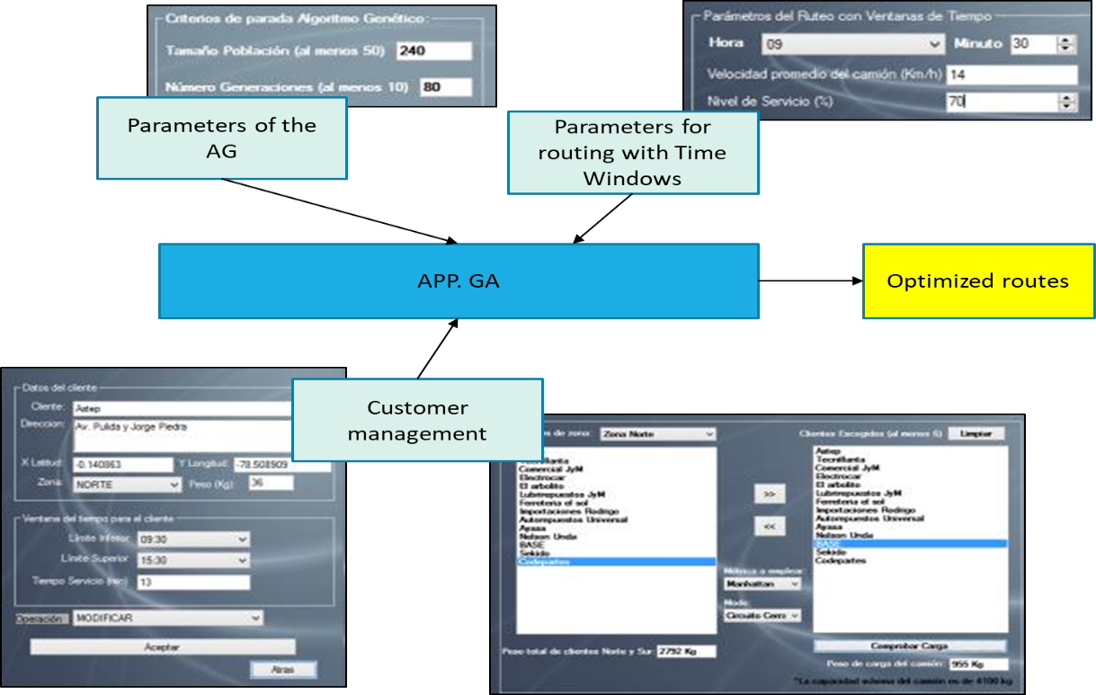

Figure 3. Architecture of the vehicle routing application developed

**2.11. Customer database**

The data of the different customers were inserted as a database in Office Acces 2007. Taken from a sample corresponding to the routes of a certain day of the company and classified by zone. The data of each customer are: identification of each customer, their description, address, latitude and longitude, time windows, estimated time for service of each customer, the zone. A very important variable in the database is the weight of the goods to be delivered for each customer, which each time that a customer is assigned to

a truck, his load is aggregated and the total sum of load of customers should not exceed 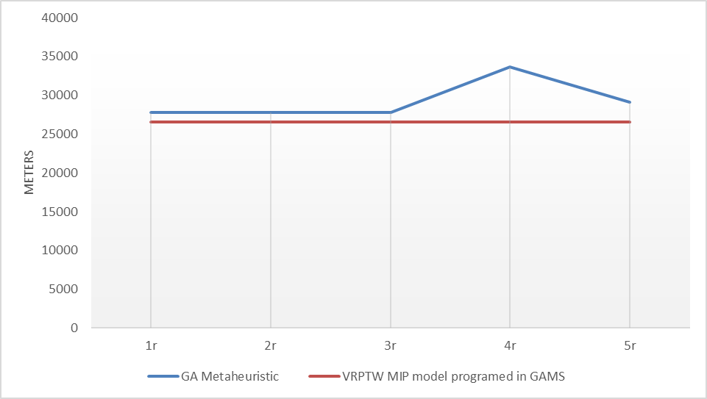the capacity of the truck.

**3. RESULTS**

The solution of the CVRPTW problem is classified as difficult to solve or "NP-hard" because of its high computational cost [11]. For example, if we have a set of $n$ cities with their respective distances, only talking about the Figure 4– Total distance travelled by the truck for

a six-node route

amount $Q$ of possible tour combinations that can be formed is given by $Q= (n-1)!$, the total distance for each tour is calculated and the one with the shortest distance is chosen. Furthermore the running time is given by $f(n)=(n)!$. I.e. for the case of $n=6$ we will have 120 possible tours and a feasible computational execution time in the order of several seconds. Since all the possible tours are displayed, but if it increases to $n=50$, the number of possible tours is equals to $49!$ (6.0828186e+62), such a large number of possibilities that would not be easily solved in several months even with the latest technology computers [8].

However, as discussed above. The strength of the heuristic procedures and genetic algorithms is in the execution time since with them a good solution can be obtained within an acceptable execution time for problems with large quantity of customer nodes.

**3.1. Evaluation of the proposed GA against a MIP model**

The evaluation of the proposed GA against a mixed integer programming model (MIP) programmed in GAMS was carried out and was discussed in point 2.8 of this study, to which the variables of time of service to customers and speed of the truck were added, as well as the arcs between customers. For the first evaluation, only six customer nodes were used for the reason explained in the previous paragraph. The execution time and the results obtained were evaluated, as shown in table 2.

Table 2. Selected customers for testing.

|  |  |  |  |  |  |  |  |  |
| --- | --- | --- | --- | --- | --- | --- | --- | --- |
| **Customer** | | | **Lower Time Window** | **Upper Time Window** | **Direction** | **X latitude coordinate** | **Y longitude**  **coordinate** | **Load [kg]** |
| Base | 1 | 9:30 | | 15:30 | Avenue. Galo Plaza Lasso y Manuel Zambrano | -0.128544° | -78.480709º | 1 |
| Sekido | 2 | 9:30 | | 15:30 | Avenue. Neptalí Godoy,sector Carapungo | -0.102861° | -78.451637º | 100 |
| Codepartes | 3 | 9:30 | | 15:30 | Avenue.Occidental N70-297 y Peripa | -0.109459º | -78.504374º | 100 |
| Astep | 4 | 9:30 | | 15:30 | Avenue. Pulida y Jorge Piedra | -0.140863º | -78.508909º | 1200 |
| Tecnillanta | 5 | 9:30 | | 15:30 | Avenue. Amazonas y el Inca | -0.159030º | -78.483367º | 500 |
| Comercial JyM | 6 | 9:30 | | 15:30 | Avenue. 10 de Agosto y Murgeón | -0.190771° | -78.493173º | 100 |

Since the MIP model of the VRPTW was programmed in GAMS, and the GA was programmed in C#, in both models the Euclidean metric was used to measure and compare the distances between customer nodes. The VRPTW model implemented in GAMS used directed graphs for the construction of the arcs as explained above, therefore the amount of possible arcs for the route was given by the expression $Qmax=n(n-1)$. Since there were six customer nodes, there would be 30 arcs for the directed network, whose distances between customer nodes or arcs were measured with the help of Google Earth Pro software. The route had to start and end at the base node with the truck leaving at 09:30 and respecting the time windows of each customer, which started from 09:30 to 15:30 as indicated above.

The service time for each customer was 13 minutes and the goal was to provide customers with a 100% service level. With the group of six selected customer nodes and the same parameters mentioned above, five runs were executed. For both applications, feasible solutions were found regarding time window restrictions. The results of these runs are shown in table 3.

Table 3. Results of the first test with 6 customer nodes

|  |  |  |  |  |
| --- | --- | --- | --- | --- |
| Instance | GA Metaheuristic | | VRPTW MIP model programed in GAMS | |
| **Total distance traveled by the truck (mts)** | **Execution time (seg)** | **Total distance traveled by the truck (mts)** | **Execution time (seg)** |
| first run (1r) | 27.816,81 | 55,33 | 26.579,67 | 1,42 |
| second run (2r) | 27.816,81 | 54,47 | 26.579,67 | 0,12 |
| third run (3r) | 27.816,81 | 55,15 | 26.579,67 | 0,12 |
| fourth run (4r) | 33.695,63 | 54,84 | 26.579,67 | 0,12 |
| fifth run (5r) | 29.128,38 | 55,11 | 26.579,67 | 0,12 |

A decrease in total distance traveled by the trucks of approximately 9.14% could be noted by applying the MIP model if we compared it with the total distance traveled by the trucks with the routing GA metaheuristics, as shown in Figure 4.

As for the execution time, a better performance of the MIP model could be noticed, improving the routing GA metaheuristics by approximately 99%. However, as mentioned before, if you increase the number of nodes this problem would be unfeasible to implement the MIP model, and in this aspect, if you have a large number of nodes only the metaheuristics would be feasible, in terms of execution time as shown in figure 5.

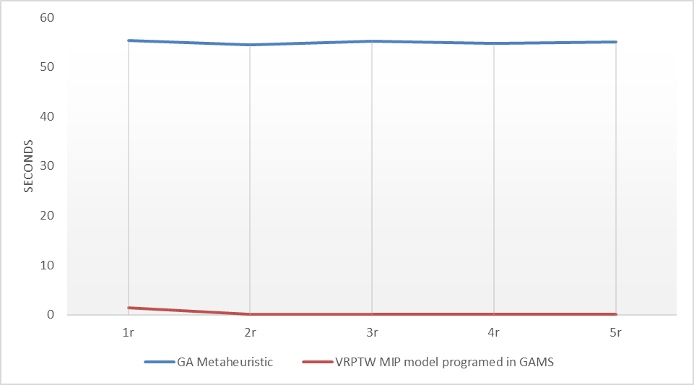The run times of the proposed GA application were recorded increasing the number of customer nodes, to observe the variation in their run times. The best stop criteria were given considering a population size of 50 individuals, and the best number of generations was 10. That is, the execution times of the application with GA were measured for 6, 9, 12, 15, 18, 21 and 24 client nodes. As shown in figure 6.

Figure 5– Execution time for the two routing models

for a six node route.

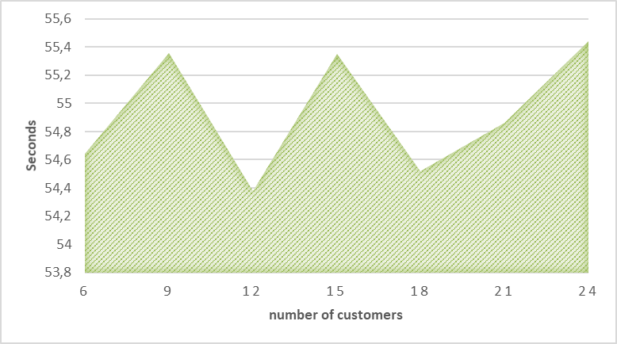Analyzing the obtained data, a constant average was noticed in the exe cution time of the proposed algorithm due to the stop criteria defined in the parameters of the GA. In general, the consistency of the developed application could be checked. Therefore, in the following

sections we evaluated the performance of the GA with the 14 real client nodes of the North route, without the need to evaluate these results against the MIP model, since it would not be feasible in terms of execution time. This is because the execution time of the MIP

Figure 6– Execution times of the metaheuristic

in relation to the number of customers

model with 14 client nodes is $13!$ = 6227020800.

**3.2. Evaluation of the proposed GA against actual distribution methodology**

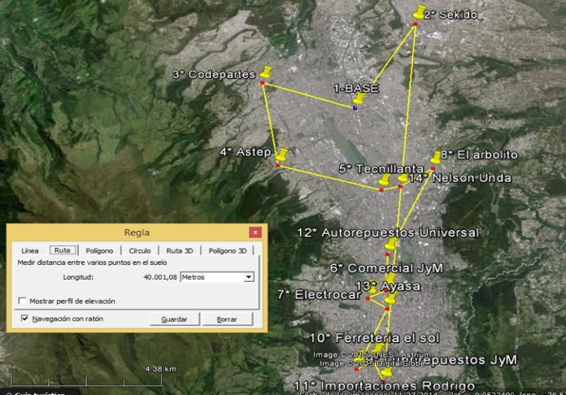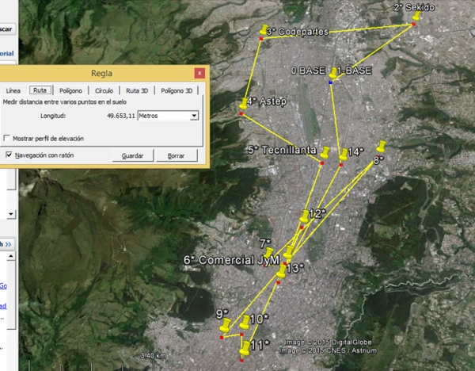

Figure 7– Real executed route sequence in the Figure 8– Optimal route sequence according northern zone GA metaheuristic for the northern zone

The result of the routing metaheuristics with GA was evaluated against the sequences of the actual delivery system, that is, the distribution routes carried out previously in a day's work by the case study company in the DMQ, with the aim of being able to identify possibilities for improvement. This is one of the practices commonly applied in vehicle route optimization works and constitutes a key step prior to Figure 7– Real executed route sequence in the

northern zone its real implementation [26]. Figures 7 and 8 show graphically the difference between a route actually travelled by a truck and its respective optimal route determined by the proposed GA metaheuristic.

**3.3. Experiments on the application of Genetic Algorithms**

Several experiments were conducted to determine how the number of generations and population size influenced the result of the proposed application and with the same client nodes of the North route, as shown in Figure 9. 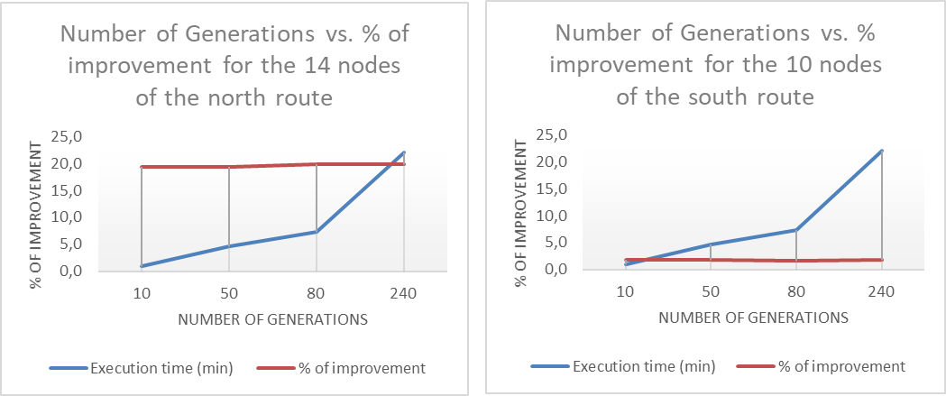

A slight improvement in the reduction of the distance travelled by the truck could be noticed by increasing the number of generations from 10 to 80. However, the execution time increased considerably, which suggests that the cost-benefit ratio should be analyzed beforehand when increasing the number of generations. In the

Figure 9- Changing the number of generations

in the GA

following experiment, the criterion of stopping the GA was set at 80 generations and we similarly analyzed how the change in the size of the initial GA population influenced Figure 9– Changing the number of generations in the GA

the result of the proposed application, the results are shown in Figure 10.

In this experiment, it was observed that increasing the population size to more than 50 individuals produced improvements in the objective function compared with the actual route. However, as in the previous experiment, the run time increased considerably, so a population size of 50

chosen because it had a good ratio of run time to solution improvements

**4. CONCLUSIONS**

The implementation of a GA-based meta-heuristics was Figure 10– Changing the population size at the GA

hybridized with the NN heuristics for the improvement of the initial population selection in the GA is a suitable alternative to providing proper solutions for the VRPTW problem. As experimentally demonstrated in this work, the execution times are all less than a minute, while reaching adequate solutions with no requiring populations greater to 50 individuals –avoiding so unnecessary raise of the computational cost.

This study uses the mathematical formulation of the VRPTW and includes in the app programming, a function that would add up the load of products in the truck and prevent further load increase each time the truck limit is exceeded, thus turning the problem into a Capacitated VRPTW or CVRPTW.

After the evaluations to which the proposed application was submitted, it was demonstrated that the solutions provided by the application in terms of route sequencing offered improvements in the total distance traveled by the truck of 19,4% for the northern route compared to the empirical sequencing that was carried out in the studied company. In addition, the GA spend short execution times. This would represent great savings in logistic costs and optimization of the distribution of auto parts for the company studied if it implements a vehicle routing system similar to the one exposed in the present and stops trusting in the empirical routing.

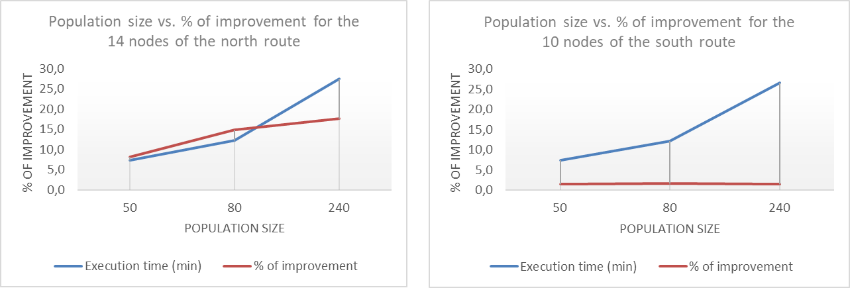The evaluation of metaheuristics with genetic algorithms against a VRPTW MIP model programmed in GAMS, shown better results of the MIP model by approximately 9% if the objective function of total distance traveled by the truck is considered. However, the implementation of the MIP model was more complicated in terms of the construction of the directed graphs for the arcs between customers and the measurement of each one of them. Which makes it difficult to implement in a real company since the amount of customer nodes in such companies oscillates between 20 or more customers for a normal working day, which as indicated above increases the

Figure 10– Changing the population size at the GA

time of elaboration of the mathematical model and the computational cost would be very high. While, the main advantage of metaheuristics with GA lies in the short execution time, since in all the executions with up to 24 customers. Its execution time did not exceed one minute, providing "good solutions" in all cases without being the most optimal solution, but without being too far away from it, and being better than the empirical routing that is currently done in the company studied. This makes it totally possible to implement the proposed model in a real auto parts distribution company. In addition, the answers given by the application can be improved by increasing the size of the population and the number of generations in the GA parameters, but would unnecessarily increase the time and cost of execution.

After the calculation of the optimal route sequences, it was possible to observe a time availability in the truck of the northern route, which could contribute to fulfill the deliveries of a truck assigned to another route. This shows the importance of previous planning of routes and transport zones and the redesign of the distribution network for the company studied. In addition, it is a possibility of improvement for this company.

The infrastructure or road network available in the DMQ due to its geography and traffic issues can be addressed by applying mathematical and metaheuristic models that consider time windows and geographic zoning of the nodes. However, as the number of these nodes increases, the problems of sequencing vehicle routes will become more difficult to solve even for the hybrid GA metaheuristics.

**ACKNOWLEDGEMENTS :**This work was supported by SDAS Research Group ([www.sdas-group.com](http://www.sdas-group.com)).

**RECEIVED: OCTOBER, 2020.**

**REVISED: APRIL , 2021**

**REFERENCES**

[1] BARBUCHA, D. (2012):. An agent-based implementation of the multiple neighborhood search for the capacitated vehicle routing problem. In **Frontiers in Artificial Intelligence and Applications**, 243, 1191–1200). https://doi.org/10.3233/978-1-61499-105-2-1191

[2] BRAEKERS, K., RAMAEKERS, K., & VAN NIEUWENHUYSE, I. (2016b):. The vehicle routing problem: State of the art classification and review. **Computers and Industrial Engineering**, *99*, 300–313.

[3] BUZAI, G. D. (2011c):. Modelos de localización-asignación aplicados a servicios públicos urbanos: análisis espacial de Centros de Atención Primaria de Salud (CAPS) en la ciudad de Luján, Argentina. **Cuadernos de Geografía-Revista Colombiana de Geografía**, *20*, 111–123.

[4] DAI, G., LI, F., SUN, Y., XU, D., & ZHANG, X. (2019d):. Convergence and correctness of belief propagation for the Chinese postman problem. **Journal of Global Optimization**, *75*, 813–831.

[5] DELGADO, E. (2012):. **Modelos avanzados en logística y transporte.**

[6] DEMORAES, F. (2015):. **Movilidad, elementos esenciales y riesgos en el Distrito Metropolitano de Quito**. Institut Français D’études Andines.

[7] ELSHAER, R., & AWAD, H. (2020):. A taxonomic review of metaheuristic algorithms for solving the vehicle routing problem and its variants. **Computers & Industrial Engineering**, *140*, 106242.

[8] GONZÁLEZ VELARDE, J. L., & RÍOS MERCADO, R. Z. (1999h):. Investigación de operaciones en acción: Aplicación del TSP en problemas de manufactura y logística. **Ingenierías**, *2*, 18–23.

[9] GUZAIROV, M. B., YUSUPOVA, N. I., SMETANINA, O. N., & RASSADNIKOVA, E. Y. (2016i):. Models and algorithms for the Vehicle Routing Problem with Time Windows and other conditions. **2016 13th International Scientific-Technical Conference on Actual Problems of Electronic Instrument Engineering, APEIE 2016 - Proceedings**, *2*, 412–416. https://doi.org/10.1109/APEIE.2016.7806502

[10] HERRERA-GRANDA, E. P., CARAGUAY-PROCEL, J. A., GRANDA-GUDIÑO, P. D., HERRERA-GRANDA, I. D., LORENTE-LEYVA, L. L., PELUFFO-ORDÓÑEZ, D. H., & REVELO-FUELAGÁN, J. (2019j):. **Drowsiness Detection in Drivers Through Real-Time Image Processing of the Human Eye BT - Intelligent Information and Database System***s* (N. T. Nguyen, F. L. Gaol, T.-P. Hong, & B. Trawiński (eds.); pp. 626–637). Springer International Publishing.

[11] HERRERA-GRANDA, I. D., IMBAQUINGO-USIÑA, W. G., LORENTE-LEYVA, L. L., HERRERA-GRANDA, E. P., PELUFFO-ORDÓÑEZ, D. H., & ROSSIT, D. G. (2019k):. **Optimization of the Network of Urban Solid Waste Containers: A Case Study BT - Technology Trends (**M. Botto-Tobar, G. Pizarro, M. Zúñiga-Prieto, M. D’Armas, & M. Zúñiga Sánchez (eds.); pp. 578–589). Springer International Publishing.

[12] HERRERA-GRANDA, I. D., LEÓN-JÁCOME, J. C., LORENTE-LEYVA, L. L., LUCANO-CHÁVEZ, F., MONTERO-SANTOS, Y., OVIEDO-PANTOJA, W. G., & DÍAZ-CAJAS, C. S. (2019l):. **Subregion Districting to Optimize the Municipal Solid Waste Collection Network: A Case Study BT - Information and Communication Technologies of Ecuador** *(TIC.EC)* (M. Botto-Tobar, L. Barba-Maggi, J. González-Huerta, P. Villacrés-Cevallos, O. S. Gómez, & M. I. Uvidia-Fassler (eds.); pp. 225–237). Springer International Publishing.

[13] HERRERA-GRANDA, I. D., LORENTE-LEYVA, L. L., PELUFFO-ORDÓÑEZ, D. H., VALENCIA-CHAPI, R. M., MONTERO-SANTOS, Y., CHICAIZA-VACA, J. L., & CASTRO-OSPINA, A. E. (2018):. **Optimization of the University Transportation by Contraction Hierarchies Method and Clustering Algorithms BT - Hybrid Artificial Intelligent Systems** (F. J. de Cos Juez, J. R. Villar, E. A. de la Cal, Á. Herrero, H. Quintián, J. A. Sáez, & E. Corchado (eds.); pp. 95–107). Springer International Publishing.

[14] HERRERA GRANDA, I. D. (2017):. **Diseño y evaluación de un algoritmo genético para ruteo vehicular que permita optimizar la distribución en una empresa comercializadora de autopartes en Quito.** Espol.

[15] HOLLAND, J. H. (1992o):. **Adaptation in natural and artificial systems: an introductory analysis with applications to biology, control, and artificial intelligence** (The MIT Press (ed.); Second). MIT press.

[16] HOLLAND, J. H. (1992p):. Genetic algorithms. **Scientific American**, *267*, 66–72. https://doi.org/10.1038/scientificamerican0792-66

[17] LIU, C., TAO, W., ZHAO, C., LI, X., SU, Y., & SUN, Z. (2019q):. Research on vehicle routing problem with time windows based on the dragonfly algorithm. **Proceedings - IEEE 17th International Conference on Dependable, Autonomic and Secure Computing, IEEE 17th International Conference on Pervasive Intelligence and Computing, IEEE 5th International Conference on Cloud and Big Data Computing, 4th Cyber Scienc**, 142–148. https://doi.org/10.1109/DASC/PiCom/CBDCom/CyberSciTech.2019.00037

[18] LORENTE-LEYVA, L. L., HERRERA-GRANDA, I. D., ROSERO-MONTALVO, P. D., PONCE-GUEVARA, K. L., CASTRO-OSPINA, A. E., BECERRA, M. A., PELUFFO-ORDÓÑEZ, D. H., & RODRÍGUEZ-SOTELO, J. L. (2018):. **Developments on Solutions of the Normalized-Cut-Clustering Problem****Without Eigenvectors BT** *- Advances in Neural Networks – ISNN 2018* (T. Huang, J. Lv, C. Sun, & A. V Tuzikov (eds.); pp. 318–328). Springer International Publishing.

[19] MARTÍNEZ-OROPEZA, A., CRUZ-CHÁVEZ, M. A., CRUZ-ROSALES, M. H., BERNAL, P. M., & PERALTA-ABARCA, J. D. C. (2012):. Unsupervised clustering method for the capacited vehicle routing problem. **Proceedings - 2012 9th Electronics, Robotics and Automotive Mechanics Conference, CERMA 2012**, 211–216. https://doi.org/10.1109/CERMA.2012.41

[20] MARTI, R. (2003t):. Procedimientos metaheurısticos en optimización combinatoria. **Matemátiques, Universidad de Valencia**, *1*, 3–62.

[21] MEDINA, J. R., & YEPES, V. (2000):. Optimización de redes de distribución con algoritmos genéticos. **Actas Del IV Congreso de Ingenierıa Del Transporte**, *1*, 205–213.

[22] MICHALEWICZ, Z. (2013):. **Genetic algorithms+ data structures= evolution programs.** Springer Science & Business Media.

[23] MICHALLET, J., PRINS, C., AMODEO, L., YALAOUI, F., & VITRY, G. (2014):. Multi-start iterated local search for the periodic vehicle routing problem with time windows and time spread constraints on services. **Computers and Operations Research**, *41*, 196–207. https://doi.org/10.1016/j.cor.2013.07.025

[24] MOUJAHID, A., INZA, I., & LARRANAGA, P. (2008x):. Tema 2. algoritmos genéticos. **Departamento de Ciencia de La Computación e Inteligencia Artificial Universidad Del País Vasco-Euskal Herriko Unibertsitatea**, 1–33. http://www.sc.ehu.es/ccwbayes/docencia/mmcc/docs/t2geneticos.pdf

[25] RAMSER, R. & G. DANTZIG. (1959):. **The Truck Dispatching Problem** *\**. *6*(1), 80–91. https://search.proquest.com/openview/c04c262295630a6300f22479019aa52d/1.pdf?cbl=40738&pq-origsite=gscholar

[26] ROSSIT, D. G., VIGO, D., TOHMÉ, F., & FRUTOS, M. (2019):. Visual attractiveness in routing problems: A review. **Computers & Operations Research**, *103*, 13–34.

[27] SKRLEC, D., FILIPEC, M., & KRAJCAR, S. (1997):. A heuristic modification of genetic algorithm used for solving the single depot capacited vehicle routing problem. **Proceedings - Intelligent Information Systems, IIS 1997**, 184–188. https://doi.org/10.1109/IIS.1997.645214

[28] TOTH, P., & VIGO, D. (2002):. The vehicle routing problem. In Society for Industrial and Applied Mathematics (Ed.), **Optimization** (first, Vol. 9). https://doi.org/10.1137/1.9780898718515

[29] TOTH, P., & VIGO, D. (2014):. Vehicle routing: problems, methods, and applications. SIAM. https://epubs.siam.org/doi/pdf/10.1137/1.9781611973594.fm

[30] VIDAL, T., CRAINIC, T. G., GENDREAU, M., & PRINS, C. (2013):. A hybrid genetic algorithm with adaptive diversity management for a large class of vehicle routing problems with time-windows. **Computers & Operations Research**, *40*, 475–489. https://doi.org/https://doi.org/10.1016/j.cor.2012.07.018

[31] YELMEWAD, P., & TALAWAR, B. (2020ae):. GPU-based Parallel Heuristics for Capacited Vehicle Routing Problem. **Proceedings of CONECCT 2020 - 6th IEEE International Conference on Electronics, Computing and Communication Technologies**. https://doi.org/10.1109/CONECCT50063.2020.9198667

**.**

1. ishergra@doctor.upv.es, ²iherrer@espol.edu.ec